December18, 2020
Dear Elders, Families and Friends of MSS,

We have been notified that two elders from Traceway Manor have been diagnosed with COVID-19. The elders are quarantined and are receiving appropriate care. We have notified public health officials and are following all recommendations provided by the CDC and the Mississippi State Department of Health.

We have contacted all elders and employees who may have been exposed to make them aware of the situation. Please know that we have followed, and will continue to do so, all guidance set forth by state and federal officials for privacy, elder care, employee safety, and efforts to stop the spread of COVID-19.

As a reminder, The Manor is currently on quarantine until we are clear of infection. We are asking all elders to remain in their apartments to ensure that the virus is not spread. All in-person dining, group gatherings, group activities and family visiting has been suspended at this time.

Mississippi is currently seeing very large numbers of infections diagnosed each day and we must remain vigilant in order to prevent further infection at Traceway. Lee County has a positivity rate of 19.5% which is among the highest in the state. It is highly critical that everyone continue to follow all the safety protocols necessary for slowing the spread of the virus. Please continue to practice social distancing, wearing a mask, performing good hand sanitation and whenever possible, avoid being out in the general public. As long as the virus is widespread in our state, the harder it will be to keep it out of our facility and the greater the chance that another elder or employee will be affected.

As a reminder, we are posting regular updates online and our dedicated message line. You can call 662-844-8977 Ext. 224 for a pre-recorded message or go to mss.org/Traceway and click on the COVID-19 Update Button. As always, you can reach out to our administrative office at Traceway for any questions you may have.

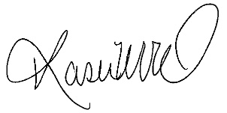
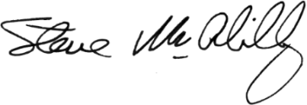
Sincerely,
For God has not given us a spirit of fear, but one of power, love, and sound judgement. ~ 2 Timothy 1:7

Steve McAlilly Kasie Wood
President/CEO Traceway Executive Director

